Neuroscience
Biological psychology: a branch of psych concerned with the links between biology and behavior.

The Nervous System:

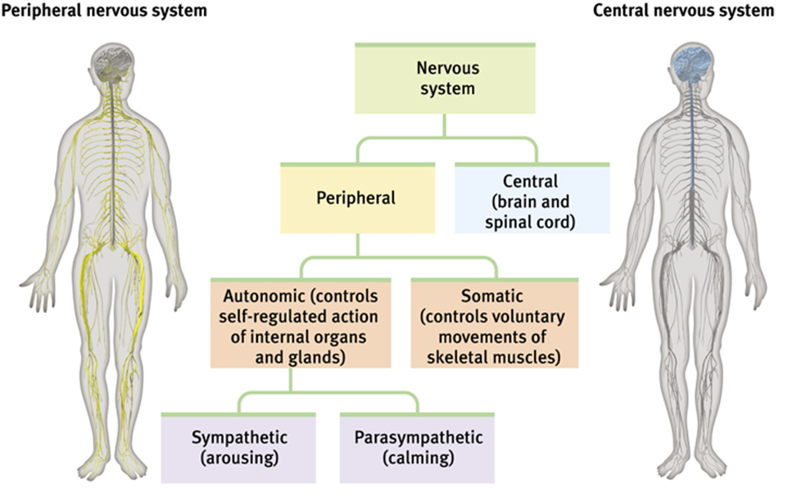
Nervous system: the body’s speedy electrochemical communication network, consisting of all the nerve cells of the peripheral and central nervous system.

Central nervous system (CNS): the brain and spinal cord.

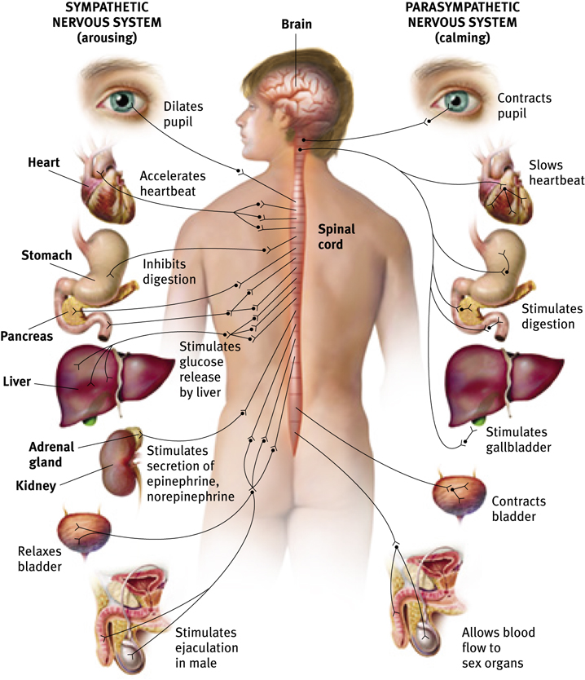
Peripheral nervous system (PNS): connects CNS to the limbs and organs, essentially serving as a communication relay going back and forth between the brain and the extremities.

Somatic nervous system: the division of the PNS that controls the body’s skeletal muscles. Also known as the skeletal nervous system.

Autonomic nervous system: the part of the PNS that controls the glands and the muscles of the internal organs. Controls the sympathetic and parasympathetic nervous systems.

Sympathetic nervous system: the division of the autonomic nervous system that arouses the body, mobilizing its energy in stressful situations. “Flight or flight”

Parasympathetic nervous system: the division of the autonomic nervous system that calms the body, conserving its energy. “Rest and disgest”

Reflex: a simple, automatic response to a sensory stimulus, such as the knee-jerk response.
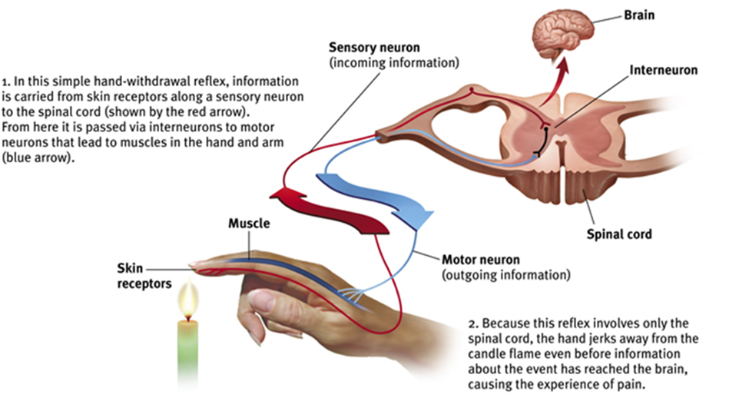

The Neuron:

Neuron: a nerve cell; the basic building block of the nervous system.

Sensory neurons: neurons that carry incoming information from the sensory receptors to the brain and spinal cord.

Interneurons: neurons within the brain and spinal cord that communicate internally and intervene between the sensory inputs and the motor outputs.

Motor neurons: neurons that carry outgoing information from the brain and spinal cord to the muscles and glands.

Soma (cell body): the neuron’s life support center that also produces neurotransmitters.

Dendrite: the bushy, branching extensions of a neuron that receive messages and conduct impulses toward the cell body.

Axon: the extension of a neuron, ending in branching terminal fibers, through which messages pass to other neurons, muscles, or glands.

Myelin sheath: a layer of fatty tissue that covers the axon which aides in the speed of neural impulses; the thicker the myelin sheath, the faster the impulse. If the myelin sheath degenerates, it could lead to multiple sclerosis (communication to muscles slows, with eventual loss of muscle control).

Nodes of Ranvier: spaces between the myelin.

Schwann cell: produces myelin.

Action potential: a neural impulse; a brief electrical charge that travels down an axon.
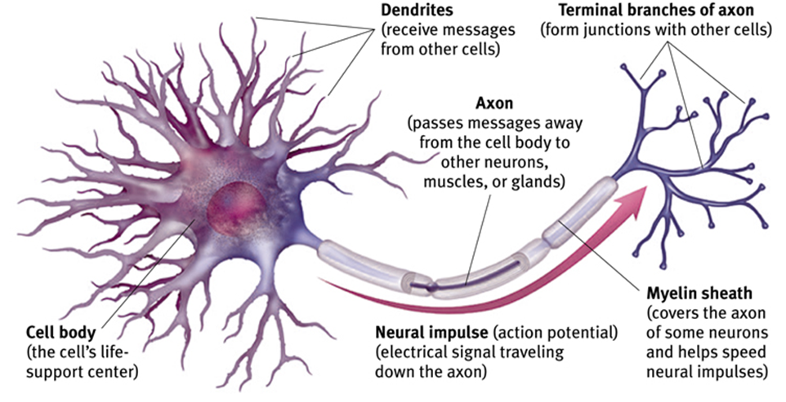

Ions: electrically charged atoms.

Resting potential: the fluid interior of a resting axon has an excess of negatively charged ions, while the fluid outside the axon membrane has more positively charged ions. (Positive-outside/negative-inside state).

Selectively permeable: the axon’s surface is very selective about what it allows in.

Polarized: during the resting state of a neuron when the outside is positively charged and the inside is negatively charged.

Depolarized: axon is no longer at resting potential; outside is now negatively charged and inside is now positively charged.

Refractory period: resting state after firing in which the neuron goes back to its polarized resting state.

Excitatory: accelerates neuron’s firing speed.

Inhibitory: slows neuron’s firing speed.

Threshold: the level of stimulation required to trigger a neural impulse.

Synapse: the junction between the terminal branch of the synaptic gap.

Synaptic gap/synaptic cleft: the tiny gap at the synapse in which neurotransmitters cross.

Neurotransmitters: chemical messengers that cross the synaptic gaps between neurons. When released by the sending neuron, neurotransmitters travel across the synapse and bind to receptor sites on the receiving neuron, thereby influencing whether that neuron will generate a neural impulse.

Reuptake: a neurotransmitter’s reabsorption by the sending neuron.

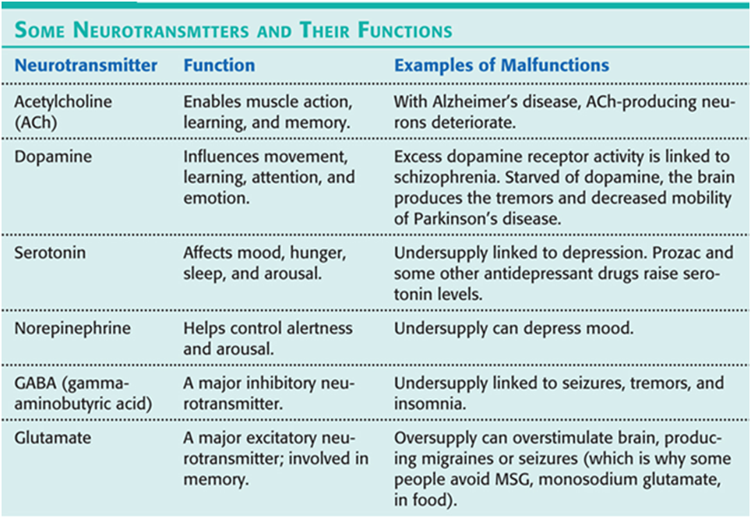

Endorphins: natural, opiate-like neurotransmitters linked to pain control and to pleasure.
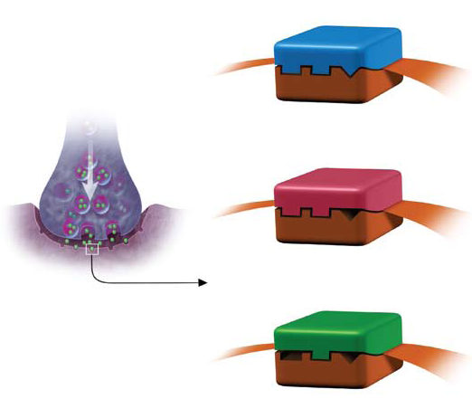
Agonist: a molecule that may be similar enough to a neurotransmitter to bind to its receptor and mimic its effects (blocks the original neurotransmitter). Ex. The body thinks morphine is close enough to the naturally made endorphins so it binds to the endorphin receptors to block pain.
Neurotransmitter

Agonist
Antagonist: a molecule that binds to receptors but blocks a neurotransmitter’s functioning.
Ex. Botulin, a poison that can form in improperly canned food, causes paralysis by blocking Ach release for muscle movement.
Antagonist

The Endocrine System:

Endocrine system: the body’s “slow” chemical communication system; a set of glands that secrete hormones into the bloodstream.
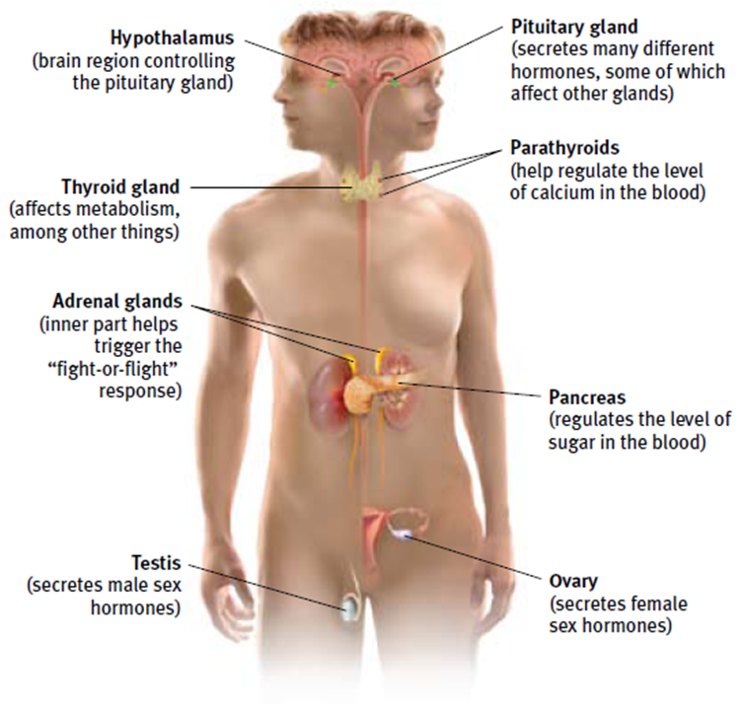
Hormones: chemical messengers that are manufactured by the endocrine glands, travel through the bloodstream, and affect other tissues.

Adrenal glands: a pair of endocrine glands that sit just above the kidneys and secrete hormones (epinphrine/adrenaline and norepinephrine/noradrenaline) that help arouse the body in times of stress.

Pituitary gland: the endocrine system’s most influential gland. Under the influence of the hypothalamus, the pituitary regulates growth and controls other endocrine glands.

The Brain:

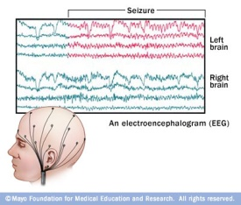
Lesion: tissue destruction that is naturally or experimentally caused to help study regions and functions of the brain.

Plasticity: the brain’s ability to modify itself after tissue damage.

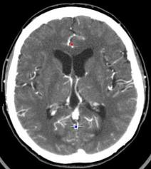
EEG (electroencephalogram): an amplified recording of the waves of electrical activity that sweep across the brain’s surface.

CT/CAT (computed tomography): a series of x-ray photographs of the brain taken from different angles and combined by computer to create an image that represents a slice through the brain.
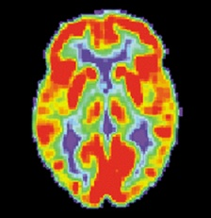
PET (positron emission tomography): measures the different levels of activity in the brain by detecting where a radioactive form of glucose goes while the brain is performing a given task.
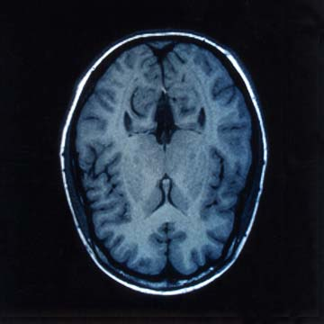
MRI (magnetic resonance imaging): uses magnetic fields and radio waves to produce computer-generated images of different structures within the brain.

fMRI (functional MRI): a technique for revealing bloodflow and, therefore, brain activity by comparing successive MRI scans. fMRI scans show brain function.
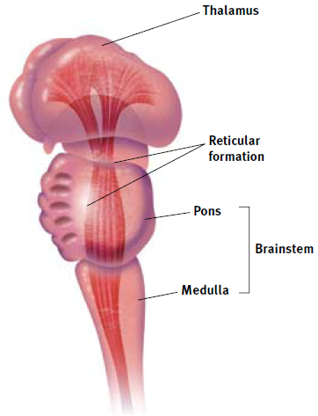
Brainstem: the oldest and innermost region of the brain that is responsible for automatic survival functions. It begins where the spinal cord swells and enters the skull.

Thalamus: the brain’s sensory switchboard located on the top of the brainstem. It directs messages to the sensory receiving areas in the cortex. It also transmits replies to the cerebellum and medulla. The sense of smell (olfaction) does not go through the thalamus.

Medulla: part of the brainstem that controls heartbeat and breathing. *Remember the 2 Ls: life and love for heartbeat and breathing.

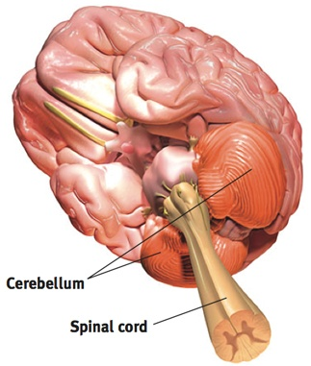
Reticular Formation: a nerve network in the brainstem that plays an important role in controlling arousal. *Remember: say the name and function together – reticularousal.

Cerebellum: the “little brain” attached to the rear of the brainstem that assists in balance and voluntary movements.

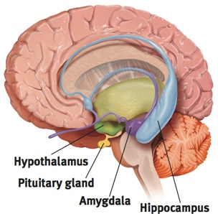
Limbic System: the doughnut-shaped system of neural structures at the border of the brainstem and cerebral hemispheres that is associated with emotions (such as fear and aggression) and drives (such as those for food and sex).

Amygdala: two almond-shaped neural clusters in the limbic system that are linked to emotions, especially fear, rage, and aggression. *Remember: Amy – grrrrrrrr

Hypothalamus: located in the limbic system that lies below (hypo) the thalamus. It is responsible for the regulation of body maintenance such as eating, drinking, and body temperature. *Remember: if your body temperature drops, you get hypothermia.

Hippocampus: the part of the limbic system responsible for memory and learning.
*Remember you do a lot of learning and memorization at a college CAMPUS .

Pituitary gland: master endocrine gland located in the limbic system.

Cerebral cortex/cerebrum: the thin layer of interconnected neural cells that forms a surface layer on the cerebral hemispheres (like bark on a tree). It is the body’s ultimate control and information processing center. It is what makes humans upper-level thinking beings as opposed to animals.

Glial cells: “glue cells” in the cortex that guide neural connections, provide nutrients and insulating myelin, and mop up ions and neurotransmitters.

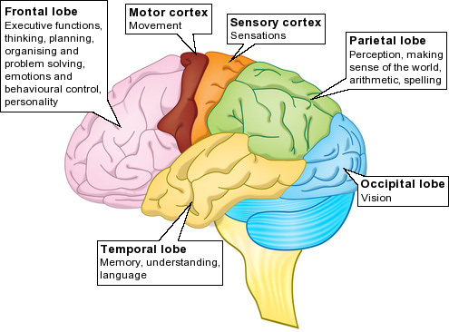
Frontal lobes: the portion of the cerebral cortex that lies just behind the forehead that is involved in speaking, muscle movements, and in making plans and judgments. It also includes the motor cortex. *Remember: when you misspeak or do something wrong, you hit your forehead…doh!

Motor cortex: the area at the back of the frontal lobes that controls voluntary movements.

Parietal lobes: the portion of the cerebral cortex between the frontal and occipital lobes that is deals with body sensations. It includes the (somato)sensory cortex.

(Somato)sensory cortex: the area at the front of the parietal lobe that registers and processes body sensations.

Occipital lobes: the portion of the cerebral cortex at the back of the brain that includes the visual cortex for vision.

Visual cortex: the area of the occipital lobe that receives visual information from the eyes.

Temporal lobes: the portion of the cerebral cortex that lies roughly above the ears that includes the auditory cortex for hearing (audition). *Remember: the temporal lobes are near the temples.

Auditory cortex: the area of the temporal lobe that receives auditory information from the ears.

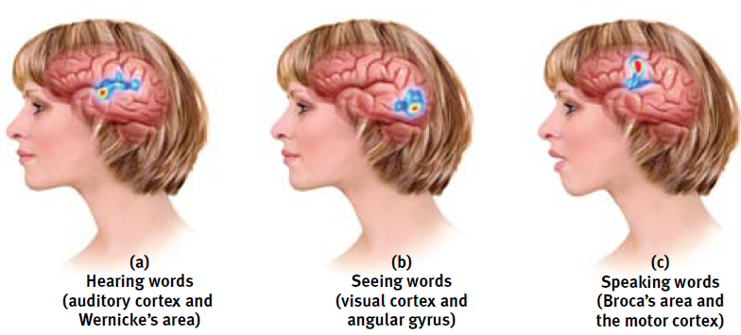
Association areas: the areas of the cerebral cortex involved in higher mental functions such as learning, remembering, thinking, and speaking. *Remember: the association areas let people make associations between things. Ex. my stomach is growling, I must be hungry.

Broca’s Area: an area of the left frontal lobe that controls the muscle movements involved in speech. Damage to this area impairs speaking.

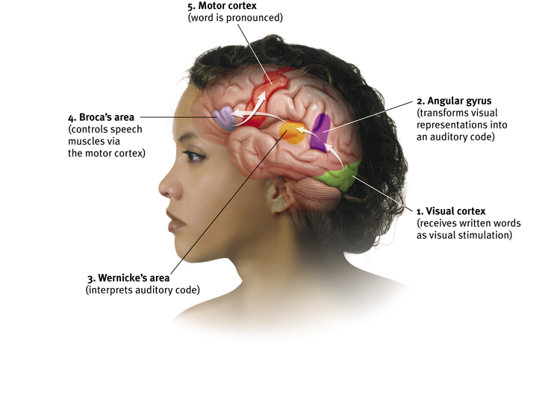
Wernicke’s Area: an area of the left temporal lobe that is involved in language comprehension. Damage to this area impairs understanding.

Angular gyrus: an area of the left occipital lobe that transforms visual representation into an auditory code.

Aphasia: impairment of language usually caused by damage to the Broca’s Area or the Wernicke’s Area.

Neurogenesis: the formation of new neurons.

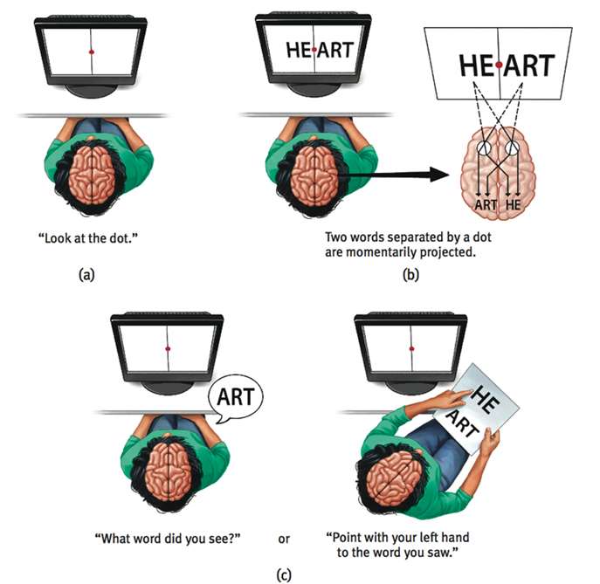
Corpus callosum: the large band of neural fibers that connect the left and right hemispheres to carry messages between them. If the corpus callosum is severed, the two hemispheres cannot communicate.

Split brain: a condition in which the two hemispheres of the brain cannot communicate. This is caused by the severing of the corpus callosum.

Alien Hand Syndrome: a rare neurological disorder that causes hand movement without the person being aware of what is happening or having control over the action. This usually occurs after a person has had the two hemispheres of the brain surgically separated, as in split-brain surgery.

Cognitive neuroscience: the interdisciplinary study of the brain activity linked with cognition (including perception, thinking, memory and language).

Dual processing: the principle that information is often simultaneously processed on separate conscious and unconscious tracks.

Neuroscience Key People:

Franz Gall: invented phrenology, an ill-fated theory that claimed bumps on the skull could reveal our mental abilities and our character traits.

Phineas Gage: 1800s railroad worker who had a tamping iron shoot through his left cheek and out the top of his skull. He miraculously lived but massively damaged his frontal lobes. The once calm and rational Gage became irritable and dishonest. This paved the way for research on the functions of the frontal lobes.

Roger Sperry, Ronald Myers, and Michael Gazzaniga: divided the brains of cats and monkeys with no serious ill effects. Set the stage to study split brain in people.

Philip Vogel and Joseph Bogen: tried to alleviate seizures in epileptic patients by severing the corpus callosum and causing “split brain” patients.

