Final Exam Review Guide

Below you will find some multiple choice and DBQ style questions based on each of the units cover in World History. These questions are designed to highlight key themes from each unit. The questions come from various sources and should help with your study as you prepare for the NCFE. However, this is not an all comprehensive review guide. There may be concepts on the NCFE not covered on this guide. It is important that you also use other resources provided on BlackBoard to aid in your preparation.

Directions:
Answer the questions from each unit by either circling the correct answer or writing a short constructed response. Constructed responses are not intended to be essays, however it is not enough to list facts. Use complete sentences and provide examples when necessary.

Unit 1: River Valley Civilizations

- Human society changed significantly from the Paleolithic Period to after the Neolithic Revolution.
a. Define the Neolithic Revolution.
b. Identify and explain three examples how human societies changed.

- One way in which the caste system in traditional India and the Estates system of pre-revolutionary France are similar is that
(a) occupations were obtained by merit (b) social mobility was very limited
(c) status was determined by education (d) impact on the daily lives of people was minimal

- Base your answer on the quotation below and on your knowledge of social studies.
“Long before the rule of pharaohs, Egyptians grew wheat and barley and raised pigs, goats, sheep and cattle. Spotty evidence had suggested that agriculture was practiced there more than 7,000 years ago, two millenniums earlier than the first royal dynasties.…
— John Noble Wilford, New York Times,
Which period in history is referred to in this excerpt?
(a) Industrial Revolution (c) Neolithic Revolution
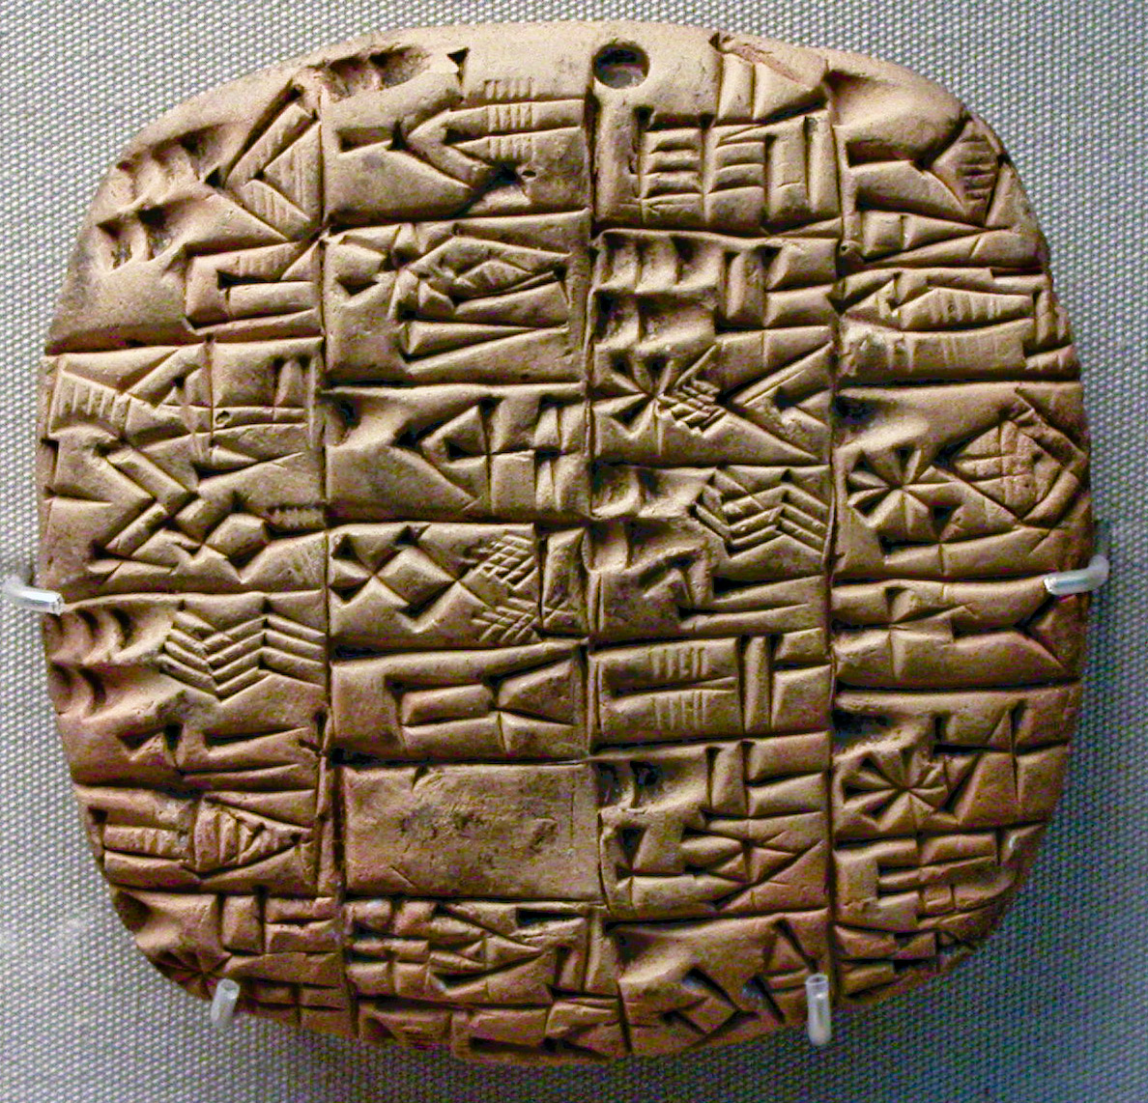
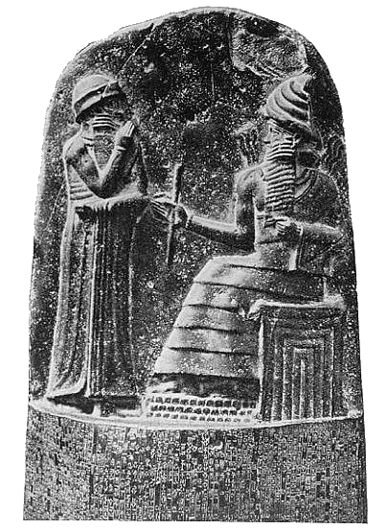
(b) Scientific Revolution (d) Green Revolution

- What are the two images to the right referring to? What River Valley Civilization are they associated with? Explain their significance.

Unit 2: World Religions
- Which belief system is considered monotheistic?
(a) Judaism (c) Confucianism
(b) Hinduism (d) Buddhism
- A person who practices Hinduism would most likely
(a) believe the Vedas are sacred (c) worship in a synagogue
(b) pray facing Mecca (d) make a pilgrimage to Jerusalem

- Match the beliefs/concepts with the appropriate religion. (Hinduism, Buddhism, Judaism, Christianity, or Islam) Some religions may be used with the same concept.
  - Karma b. Reincarnation c. Nirvana d. Four Noble Truths e. Hajj f. Mecca g. Torah i. Ten Commandments j. Caste System k. Prince Siddhartha l. Mohammed m. no known founder n. Jesus o. India p. Saudi Arabia q. Israel

Unit 3: Greece and Rome

- What was one of the most important contributions of the Greek city-state of Athens?
(a) development of direct democracy (b) diffusion of a monotheistic belief system
(c) promotion of the equality of all humans (d) creation of a writing system using hieroglyphics

- Which geographic factor contributed to the formation of independent city-states in ancient Greece?
(a) tropical rainforests (c) fertile farmland
(b) navigable rivers (d) mountainous topography

- A major impact of Ancient Greece and Rome on Western Civilization in the following categories
  - Art/Architecture
  - Government/Politics
  - Philosophy

- A major effect of the decline of the Roman Empire was that Western Europe
  - cam under the control of the Muslims
  - was absorbed by the Byzantine Empire
  - returned to a republican form of government
  - entered a period of chaos and disorder
Unit 4: The MIddle Ages

1. Use the explanation and chart below to answer the question that follows.

Feudalism was a political, economic, and social system in which nobles were granted the use of land that legally belonged to the king. In return, the nobles agreed to give their loyalty and military services to the king. The peasants or serfs worked the land for the knights and nobles and in return they received protection and a portion of the harvest to feed their families. The image below shows the structure of feudal society – a social, political, and economic hierarchy. Source: World History Patterns of Interaction

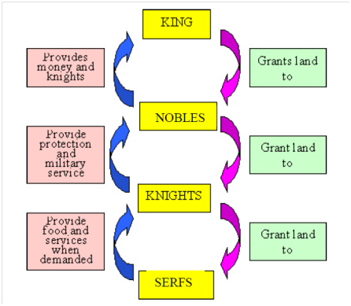

How did feudalism provide for the security of the people of medieval Europe?

2. Name and explain five combining factors that changed Europe from a once flourishing Roman Empire into what we now know as the Middle Ages.

3. What were the Crusades? Why are they known as “successful failures”?

4. Use your prior knowledge and the information in the document below to answer the question below.

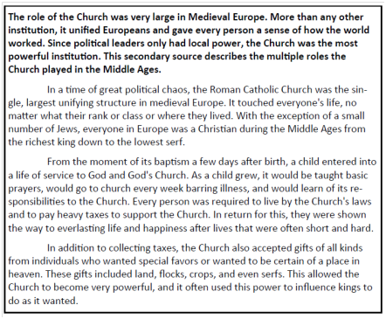

What role did the Roman Catholic Church play during the Middle Ages?

5. Explain the significant conflicts in medieval Europe…
a. Struggles between popes and emperors (Pope Gregory and Henry IV) –
b. Struggles between kings and nobles (Magna Carta, Crusades, parliament, common law) –
c. Beginning nation-states (Hundred Year’s War) –
Unit 5: The Renaissance and Reformation

- This excerpt is from The Civilization of the Renaissance in Italy, (1878) by Jacob Burchhardt.
In the Middle Ages, both sides of human consciousness lay dreaming or half awake beneath a common veil. The veil was woven of faith, illusion, and childish prepossession….man was conscious of himself only as member of a race, people, party, family, or corporation-only through some general category. In Italy this veil first melted into air…; man became a spiritual individual, and recognized himself as such. In the same way the Greek had once distinguished himself from barbarian….
When this impulse to the highest individual development was combined with a powerful and varied nature …then arose the “all-sided man”…in Italy at the time of the renaissance we find artist who in every branch created new and perfect works, and who also made the greatest impression as men. According to historian Jacob Burchhardt, was there a difference or similarity between the people of the Middle Ages and people of the Renaissance? What were the differences or similarities? What do you think the author means by “who also made the greatest impression as men”?

- Which economic system is most closely associated with the activities shown in this art work?
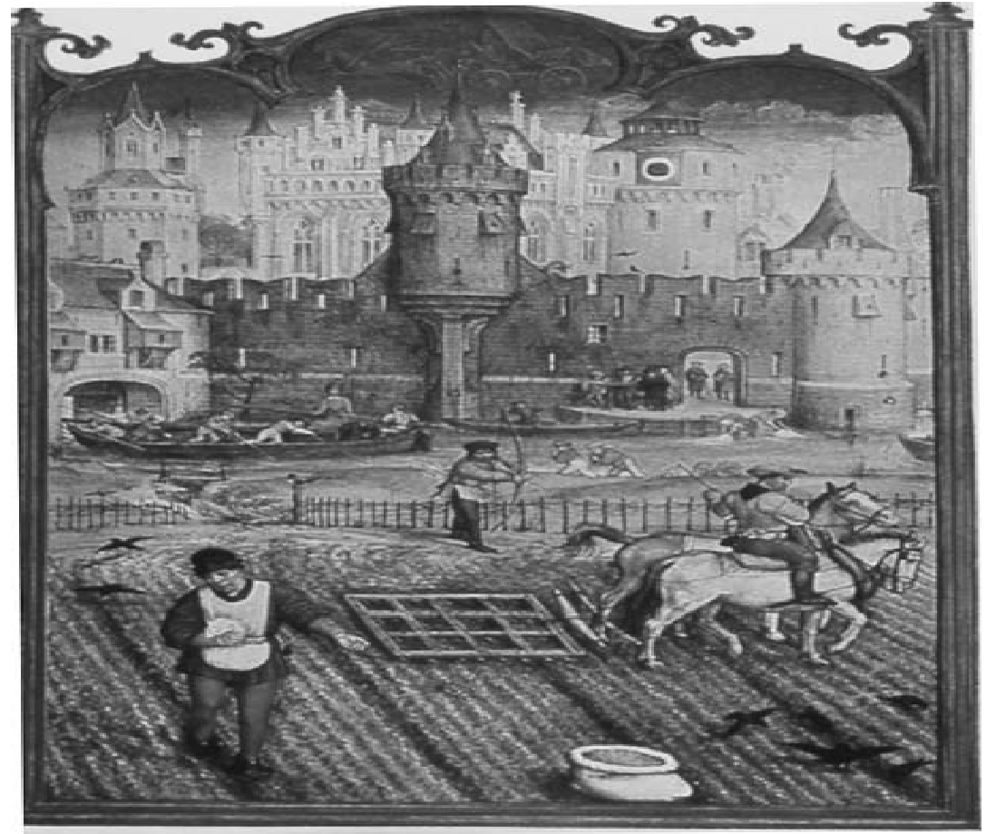
A) manorialism B) capitalism C) communism D) socialism

- How did Johann Gutenberg’s invention, the printing press, affect Europe in the late 1400s and 1500s?
- Books quickly became collectors’ items and sold for very large sums of money.
- More people learned to read, and they gained access to a broad range of knowledge.
- The printing press provided hundreds of jobs for Chinese pressmen.
- Outraged rulers banned the use of the press, fearing it would be used for producing propaganda

- All of the following were causes of the Reformation EXCEPT
- 100 Years War and Black Death.
- Scientific advances which contradicted with the Church teachings.
- The desire to spread Islam to Western Europe
- The corruption within the Catholic Church.

- Which of the following contributed to the birth of the Renaissance in Italy?
- A new translation of the Bible
- A wealthy and powerful merchant class
- The development of oil painting
- The rise of Protestantism

Unit 6: European Exploration

- Which of the following was a major result of the Age of Exploration?
A) A long period of peace and prosperity for the nations of Western Europe
B) Extensive migration of people from the Western Hemisphere to Europe and Asia
C) The fall of European national monarchies and the end of the power of the Catholic Church
D) The end of regional isolation and the beginning of a period of European global domination

- Which of these events during the Age of Exploration was a cause of the other three?
A) Europeans brought food, animals, and ideas from one continent to another
B) European diseases had an adverse effect on the native populations of new territories
C) Warfare increased as European nations competed for land and power
D) Advances in learning and technology made long ocean voyages possible

- What was the Columbian Exchange? How did it impact people in Europe and the New World?

- The Crusades indirectly contributed to the discovery of the New World by
a. Forcing the religious conversion of the Muslim population
b. Forcing the Turks to flee from Constantinople
c. Stimulating Europeans demand for goods from the East
d. Increasing the power of the feudal lords

What is the best title for this map?
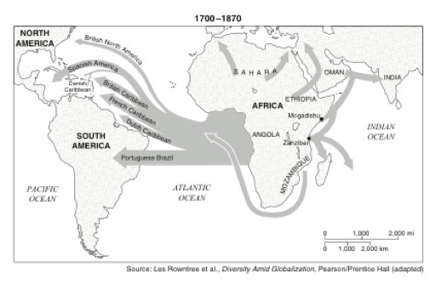

A) Gold and Petroleum Trade Routes B) Sources and Destinations of Enslaved Africans
C) Obstacles to Colonization of the Western Hemisphere D) Origin and Spread of Nationalist Revolutions

What was the Middle Passage? What is the significance to the Triangular Trade system during the Age of Exploration?

Unit 7: Absolutism, The Scientific Revolution, and Enlightenment

1. Who is the main person in this cartoon? What is the cartoon describing?
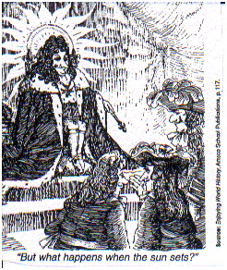

2. “. . .The person of the King is sacred, and to attack him in any way is an attack on religion itself. Kings represent the divine majesty and have been appointed by Him to carry out His purposes. Serving God and respecting kings are bound together.”
—Bishop Jacques Bossuet
This statement describes the philosophy that existed during what time period?
What concept is being described in this passage?

3. The political liberty of the subject is a tranquility of mind, arising from the opinion each person has of his safety. In order to have this liberty, it is requisite the government be so constituted as one man need not be afraid of` another.

When the legislative and executive powers are united in the same person, or in the same body of magistrates, there can be no liberty; because apprehensions may arise, lest the same monarch or senate should enact tyrannical laws, to execute them in a tyrannical manner.

Again, there is no liberty, if the power of judging be not separated from the legislative and executive powers. Were it joined with the legislative, the life and liberty of the subject would be exposed to arbitrary control, for the judge would then be the legislator. Were it joined to the executive power, the judge might behave with all the violence of an oppressor.

The Spirit of the Laws, Montesquieu
What enlightenment idea is Montesquieu pushing for?
What does he say are the benefits of this?

4. How did the ideas of Locke, Montesquieu, Rousseau, Voltaire, and Beccaria influence the Declaration of Independence and the U.S. Constitution? Include their beliefs on natural rights, the purpose of government, and the rights of citizen.

5. What is the name of each the universal theories below?
1)___________________
2)___________________

Who is the gentleman most responsible for proving the theory in #2?

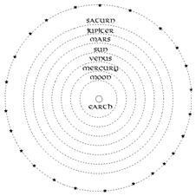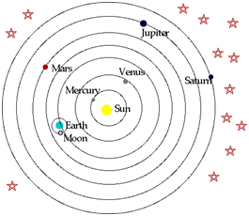

1 | 2

Unit 8: Revolutions
- Which issue was a cause of the French Revolution?
(a) ineffective rule of Napoleon Bonaparte (b) nationalization of the Church
(c) outrage over the use of the guillotine by the Committee of Public Safety
(d) demand of the Third Estate for more political power

"The pretended power of suspending [ending] of laws. ... by [the king's] authority without consent of Parliament is illegal. ... It is the right of the subjects to petition the king. ... The levying of money for ... the use of the crown ... without grant of Parliament ... is illegal. The raising and keeping of a standing army within the kingdom in time of peace unless it be with the consent of Parliament is against the law. The speech and debates ... in Parliament ought not to be ... questioned in any court or place out of Parliament. ... Excessive bail ought not to be required, nor excessive fines imposed, nor cruel or unusual punishments inflicted."
—Bill of Rights, England (1689)

"Men are born free and remain equal in rights. ... Law is the expression of the general will. Every citizen has a right to participate personally or through his representative in its [the law's] formation. ... All citizens, being equal in the eyes of the law ... no person shall be accused, arrested, or imprisoned except in the cases and according to the forms prescribed by law. No one shall be disquieted [attacked] on account of his opinions, including his religious views. ... Every citizen may speak, write, and print with freedom, but shall be responsible for such abuses of this freedom as shall be defined by law."
—Declaration of the Rights of Man and the Citizen, France (1789)

"Congress shall make no law respecting [having to do with] an establishment of religion, or prohibiting the free exercise thereof; or abridging [taking away] the freedom of speech, or of the press; or the right of the people peaceably to assemble, and to petition the government. ...
No soldier shall, in time of peace, be quartered in any house, without the consent of the owner. ...
... Nor shall [any person] be compelled ... to be a witness against himself ...
... the accused shall enjoy the right to a speedy and public trial, by an impartial jury ...; to be confronted with witnesses against him. ...Excessive bail shall not be required, nor excessive fines imposed, nor cruel and unusual punishments inflicted."
—Bill of Rights, United States (1791)

- How do the above documents illustrate cultural diffusion?

Unit 9: The Industrial Revolution
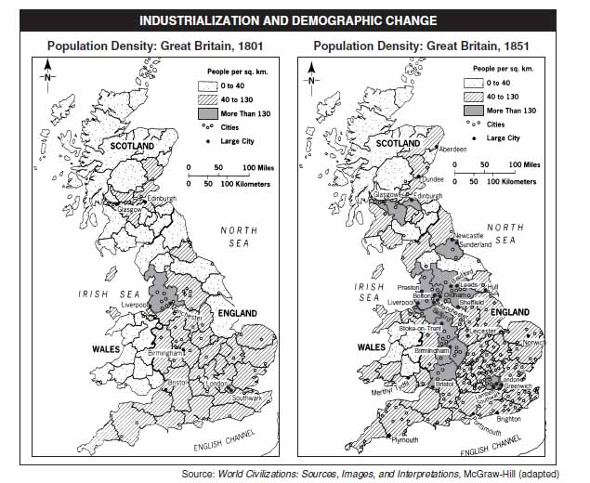
- Based on these maps, state one change that occurred in Great Britain during the Industrial Revolution and be sure to explain why.

- Which of the following did not increase as an early result of the Industrial Revolution?
  - Urbanization c. The size of the middle class
  - the length of the average work day d. The life expectancy

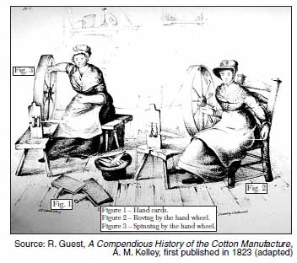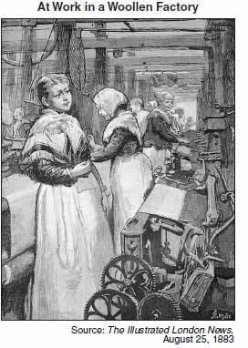

- Based on these pictures above, state two changes in how cloth was produced.

- Which is necessary for industrialization to occur?
  - A dependence on subsistence agriculture c. The availability of investment capital
  - The capture of foreign lands d. A strong monarchy

- “Minds, like bodies, will often fall into a pimpled, ill-conditioned state from mere excess of comfort.” “Day was shining radiantly upon the town then, and the high chimneys had the sky to themselves. Puffing out their poisonous volumes, they would not be long in hiding it; but, for half an hour, some of the many windows were golden.” These quotations were written by which English author who described living conditions in England during the Industrial Revolution:
  - Beethoven c. Van Gogh
  - Mann d. Dickens

Unit 10: Imperialism

- One factor that motivated imperialism during the late 19th and early 20th centuries was the
a. Development of closer political ties with European nations b. Closing of China to all foreign trade
c. Support of international peacekeeping operations d. Acquisition of new markets and sources of raw materials

2. What was the Berlin Conference of 1885-1886 notable for establishing?
- The founding of Imperialism and the establishment of the world into cores and peripheries.
- Giving independence to African colonies, but moving them into neocolonial positions within the world system.
- Bringing Africa into the world system as a carved up collection of European colonies.
d. bringing an end to the Ottoman Empire, the last of the world's great world empires

Base your answer to question 30 on the speakers’ statements below and on your knowledge of social studies.
Speaker A
: The British East India Company does not respect my beliefs. I cannot follow dharma and remain their soldier. I will return to my family in a Tamil village.
Speaker B
: My rebellious countrymen cannot accept my new religion and so they hate me and my “foreign devil” friends. The
missionaries leave Beijing tomorrow for England. I must join them before the church compound is surrounded.
Speaker C
: The czar’s soldiers came again today, looted our village, drove off our livestock, and trampled anyone in their way. They even burned our synagogue. Our way of life is gone. It is time to emigrate to Palestine.

3. What is the primary focus of these speakers?
a. civil war b. economic reforms
c. religious persecution d. colonial oppression

4. The Chinese had long been opposed to the opium trade. The drug had been introduced into China by Dutch traders during the seventeenth century. As early as 1729, there were imperial decrees forbidding the sale and smoking of this “destructive and ensnaring vice.” In 1796, Jiaqing, the new emperor, placed a complete ban on its importation, but he was a weak administrator and soon pirates and opium merchants were bribing officials to look the other way. By 1816, the [British] East India Company had imported 3,000 chests of opium from its poppy fields in the north Indian state of Punjab. By 1820, this had risen to 5,000 and by 1825 to almost 10,000.
As more and more Chinese became addicts, and silver flowed out of the economy to British coffers, the Chinese government moved toward confrontation. The emperor Daoguang, who came to the throne in 1821 was a reformer, and, supported by his advisor Lin Zexu (1785–1850), the emperor banned opium in 1836 and ordered the decapitation of “foreign barbarians” who concealed and traded the drug...
Source: Perry M. Rogers, ed., Aspects of World Civilization: Problems and Sources in History, Volume II,
Prentice Hall (adapted)

a. According to Perry Rogers, what was one reason the Chinese were unsuccessful in halting the opium trade?
b. According to Perry Rogers, what was one effort made by the Chinese to halt the European trade in opium?

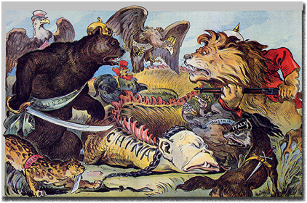

4. The political cartoon refers to what imperialism term?
a. Roosevelt Corollary c. Spheres of Influence
b. White Man’s Burden d.Boxer Rebellion

- Define imperialism. Describe two negative and two positive effects of imperialism in each of the following regions; India, Africa, and China.

Unit 11: WWI and The Russian Revolution
- The major impact of the Treaty of Versailles on Germany was that the treaty led to
- an era of peace and international good will in Germany
- a stable Germany that was both democratic and strong
- an increase in Germany’s desire to regain its power and prestige
- a leadership position for Germany in the League of Nations
- A major cause of World War I was
- a decline in the policy of imperialism c. the existence of opposing alliances
- an increase in acts of aggression by England d. the spread of communism throughout Europe

- Which concept is represented in these WWI recruiting posters?
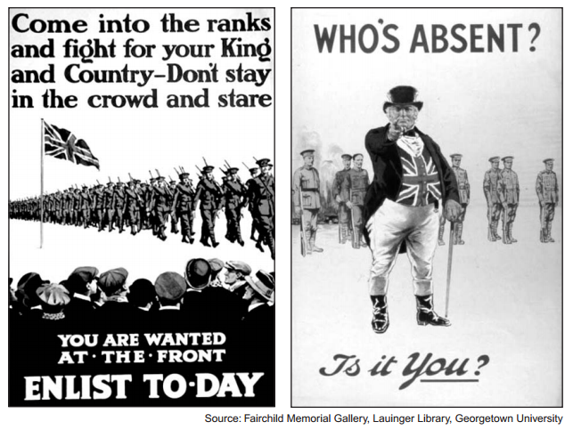
- justice b. diversity c. nationalism d. humanism

- Explain US involvement at the beginning of WWI? What were some reason why the US eventually entered into WWI?

Unit 12: WWII

Major Concepts: In complete detail, answer the following questions.
1. In what ways can the Treaty of Versailles be considered a cause of WWII?
2. How did the economic problems of the 1920’s and 1930’s help lead to the rise of Fascist Dictators?
3. Describe the major battles of Europe and their significance.
4. Describe the major battles of the Pacific and their significance.
5. Explain how attempts by the U.S. to remain neutral, and what eventually brought the Americans into the war.
6. What is the Holocaust? What groups were included in the victims? How did the world react to the Holocaust following the end of the war?
7. How were the Allies able to be victorious in WWII? What strategies and events helped to lead to an allied victory?

Review Questions:
1. The Treaty of Versailles contributed to the economic collapse of Germany after WWI by:
a. Mandating economic reforms in German b. Requiring that Germany pay for war damages
c. Placing a quota on goods exported from Germany d. Devaluing German currency

2. During WWII, which event occurred last?
a. German invasion of Poland b. Russian defense of Stalingrad
c. United States bombing of Hiroshima and Nagasaki d. Japanese invasion of Manchuria

3. Nazi Germany, Fascist Italy, and Communist Russia were similar in that each
a. Protected individual rights b. Elected their leaders through popular vote
c. Supported market-based economies d. Established totalitarian governments

Base your answer to question 4 on the passage below and your knowledge of social studies:
“ It took the Big Four just five hours and twenty-five minutes here in Munich today to dispel the clouds of war and come to an agreement over the partition of Czechoslovakia. There is to be no European war, after all. There is to be peace, and the price of that peace is, roughly, the ceding by Czechoslovakia of the Sudeten territory to Herr Hitler’s Germany. The German Fuhrer gets what he wanted, only he has to wait a little longer for it. Not much longer though-only ten days….”
Source: William Shirer, recording of CBS radio report from Prague, September 29, 1938
4. The policy that France, Britain, and Italy chose to follow at this meeting is known as:
a. Appeasement b. Self-determination
c. Liberation d. Pacification

Base your answer to question 5 on the passage below and your knowledge of social studies:
“… the key-stone of the Fascist doctrine is its conception of the State, of its essence, its functions, and its aims. For Fascism the State is absolute, individuals and groups relative. Individuals and groups are admissible in so far as they come within the State. Instead of directing the game and guiding the material and moral progress of the community, the liberal State restricts its activities to recording results. The Fascist State is wide awake and has a will of its own. For this reason it can be described as ‘ethical’….”
-Benito Mussolini, Fascism: Doctrine and Institutions, Howard Fertig, 1932
5. Which statement expresses the main idea of the passage?
a. The people have the right to overthrow ineffective governments
b. The state is more important than the individuals within it
c. The state gets its authority from the power of individuals
d. The establishment of an empire will cause division and chaos

Use the following chart to answer question 6
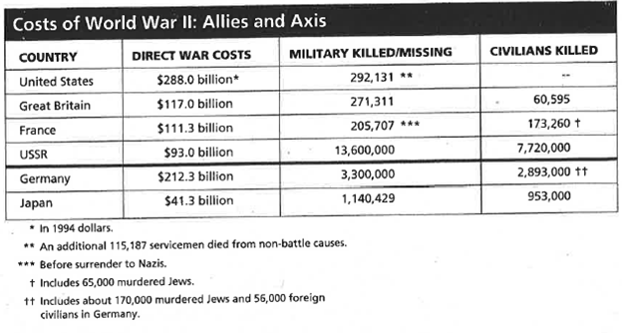
6. How many more Soviet Military personnel were killed or missing than German?
a. 7,300,000 b. 9,000,000
c. 9,300,000 d. 10,300,000

Unit 13: The Cold War

- What was the American policy designed to block the spread of Communism?
  - Détente b. SALT
- Containment d. Glasnost
- How are World War I, World War II, and the Cold War related?

- What were the purposes of NATO and the Warsaw Pact? How were they similar? Different?

- Why did the Soviet Union control satellite nations?

- During the 1980’s, the Soviet Union experimented with modifications of its command economy with the Perestroika and Glasnost policies by:
  - Eliminating central planning c. Allowing private ownership of major industries
  - Introducing some market economy strategies d. Legalizing independent trade unions

Unit 14: Modern Conflicts and Environmental Issues

1. Identify the following trends and developments

a. Globalization b. New World Order
c. Technological achievements d. Population growth
e. Urbanization f. Industrialization
g. Development of global market

2. Explain how population growth, urbanization, industrialization, warfare, and the global market economy have contributed to changes in the environment

a. Deforestation b. Pollution
c. Clear cutting d. Ozone depletion
e. Climate change f. Global warming

3. Explain how liberal democracy, private enterprise, and human rights movements have reshaped political, economic, and social life in Africa, Asia, Latin America, Europe, Soviet Union, and United States

a. UN Declaration of Human Rights b. Apartheid
c. Perestroika d. Glasnost

4. What is terrorism? Identify the following terrorist groups

a. Basque Separatists b. PLO
c. IRA d. Tamil Tigers
e. Al Qaeda f. Hamas
g. Hezbollah h. Palestinian Islamic Jihad

